**How to use the PowerPix Application**

PowerPix is a small application that allow user to use the power of the Google Search Engine to search for images on certain topics and use said image to create a PowerPoint Presentation slide with that image.

At this time, this version of PowerPix is for **developers only** and would require the following:   
 -Visual Studio 2019 (to run and test the program)  
 -Microsoft Office 365 (most preferably MS PowerPoint)  
 -Access to a Google Custom Search API key.

To get started:

-Download the project on GitHub -> <https://github.com/crhodes2/PowerPix>

-Save and unzip the project somewhere on your Desktop

Get the API Key:

-In order to use the application, you need access to the Google Custom Search API Key. Here is how to do it:

1) Click on this link -> <https://developers.google.com/custom-search/v1/overview>

2) Scroll down until you see the **Get a Key** option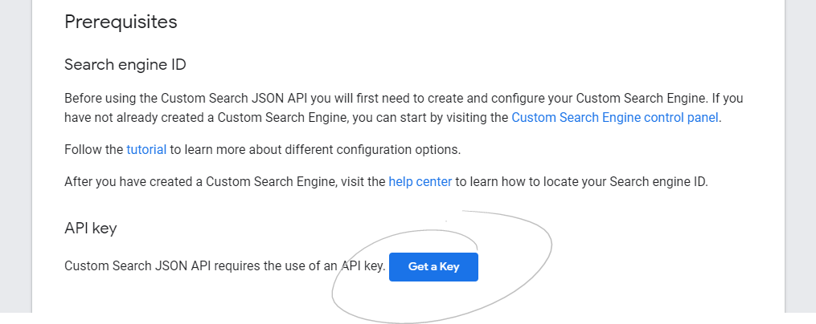

3) You will be greeted with this pop up screen. Go ahead and click on **Create a new project** andname it whatever you’d like. I’d recommend naming it by the project name itself, which is in this case, PowerPix.

If you have a Google Account, proceed with signing in. Otherwise, creating a new account is free 🡪 <https://support.google.com/accounts/answer/27441?hl=en>

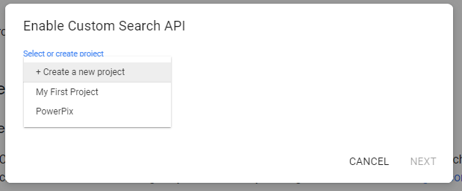

4) After following these steps, you will be greeted with a box that has your API key on it. Copy that key on a clipboard.  
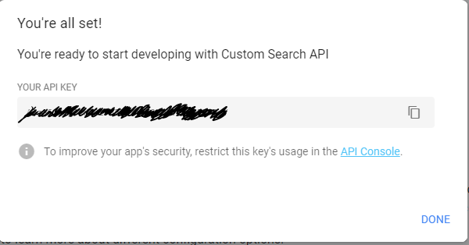

5) Go back to the project you have saved on your computer and navigate through to get to the file **App.Config.** Example: if the project was saved on your Desktop, it would be located under **"C:\Users\username\Desktop\PowerPix-master\PowerPix2.0\App.config".** Open the file using Notepad.

6) Paste your key from your clipboard to the highlighted section. Save the file and close the Notepad.

